How to install Zktech in odoo

1. Install module

hr_zk_attendance

1. Install pytz
   1. Open cmd
   2. Cd to: C:\Program Files\Python312
   3. Install: Pip3.12 install zklib

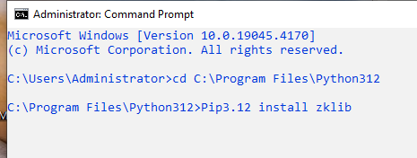

1. Restart odoo service and test it

If error install: in venv, phycharm

* pip install numpy

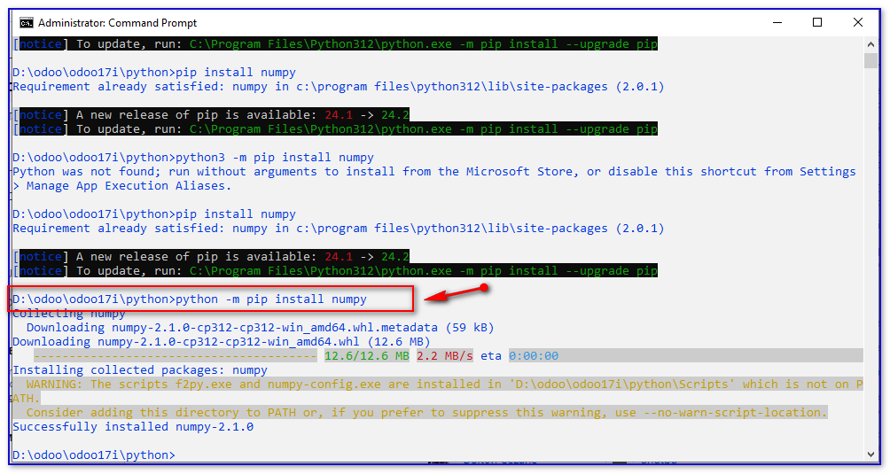

Fix error for odoo18:

Open cmd: python -m pip install Pyzk --upgrade

